**Uniform Motion**

1. On the way to school, a student decide to run across a busy road instead of using the pedestrian bridge. He sees a car 100 m away travelling towards him, but he is conﬁdent that he can cross in time.
   1. The car is travelling at 105 km h-1 and the student can run at 10 km h-1. Calculate their respective speeds in m s-1.
   2. 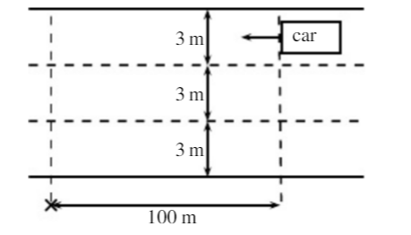If the road has 3 lanes and each lane is 3 m wide, how long will it take for the student to cross all three lanes, from kerb to kerb?
   3. If the car is travelling in the furthermost lane from the student, will he be able to cross all 3 lanes of the road safely? Provide a calculation as part of your reason.
2. In an experiment on scalar and vector quantities, student 1 throws a ball 3.20 m east to student 2. Student 2 then throws it 4.50 m west to student three. The students then measured the distance and displacement of the ball.
   1. Calculate the distance the ball travelled.
   2. Draw a diagram, then determine the ball’s displacement.
3. A plane is flying due North at 300 km h-1 and a westerly wind of 25 km h-1 is blowing it off course. Draw a vector diagram and calculate the true speed and direction of the plane.
4. A plane takes off, leaving the runway at 32° to the horizontal and travelling at 180 km h-1. If it continues to climb at this angle, how long will it take to reach an altitude of 1000 m?
5. A boat needs to travel directly from one side of a river to the other. Its speed in still water is 10.0 km h-1.
   1. If the river’s current is 5.00 km h-1, what upstream angle (relative to the river bank) must the navigator point the boat to do this? (Hint : the 10.0 km h-1 vector is in this direction and is the largest vector in the diagram.)
   2. How wide is the river if it takes the boat 2.00 minutes to cross it?